create schema dlta;

use dlta;

create table product1 (product_id int primary key,product_name varchar(100),category varchar(50),unit_price decimal(10, 2));

insert into product1 (product_id, product_name, category, unit_price)values(101, 'laptop', 'electronics', 500.00),(102, 'smartphone', 'electronics', 300.00),(103, 'headphones', 'electronics', 300.00),(104, 'keyboard', 'electronics', 20.00),(105, 'mouse', 'electronics', 15.00);

select * from product1;

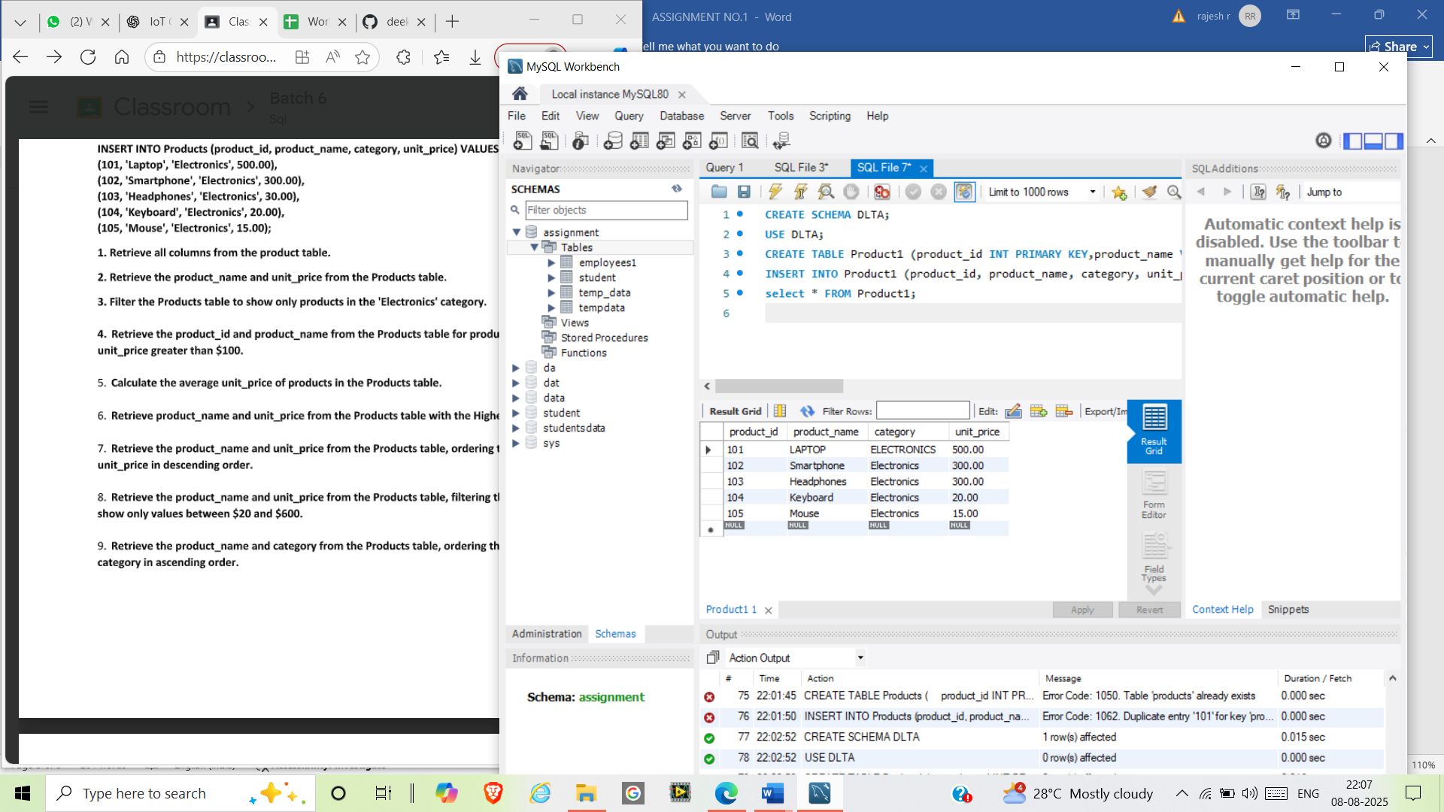

select product_name,unit_price from Product1;

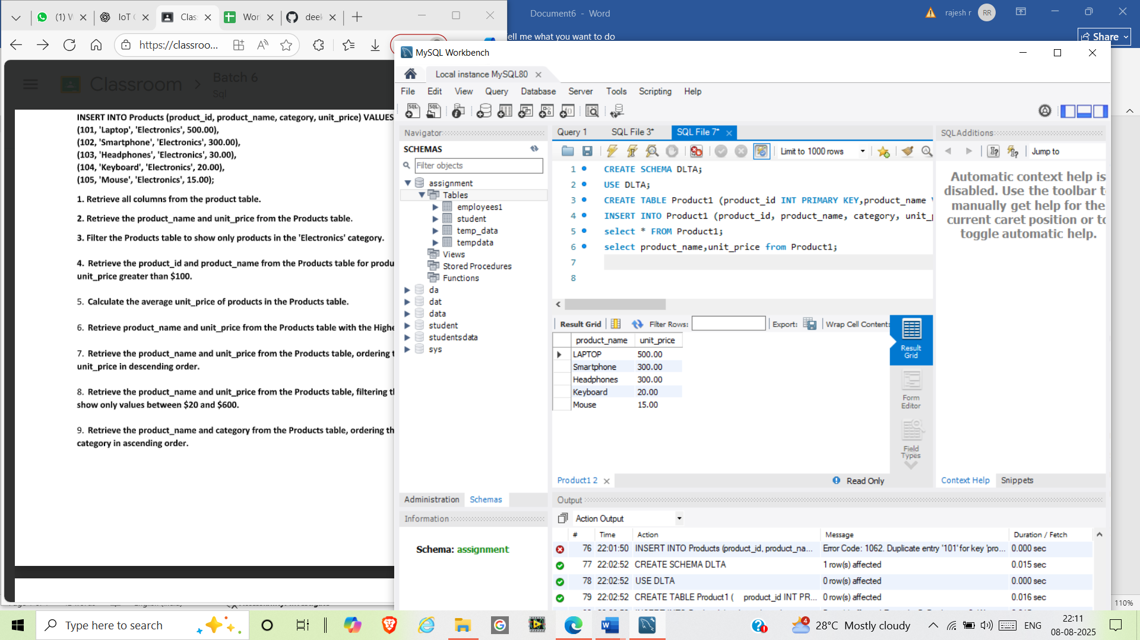

select*from Product1 where category="Electronics";

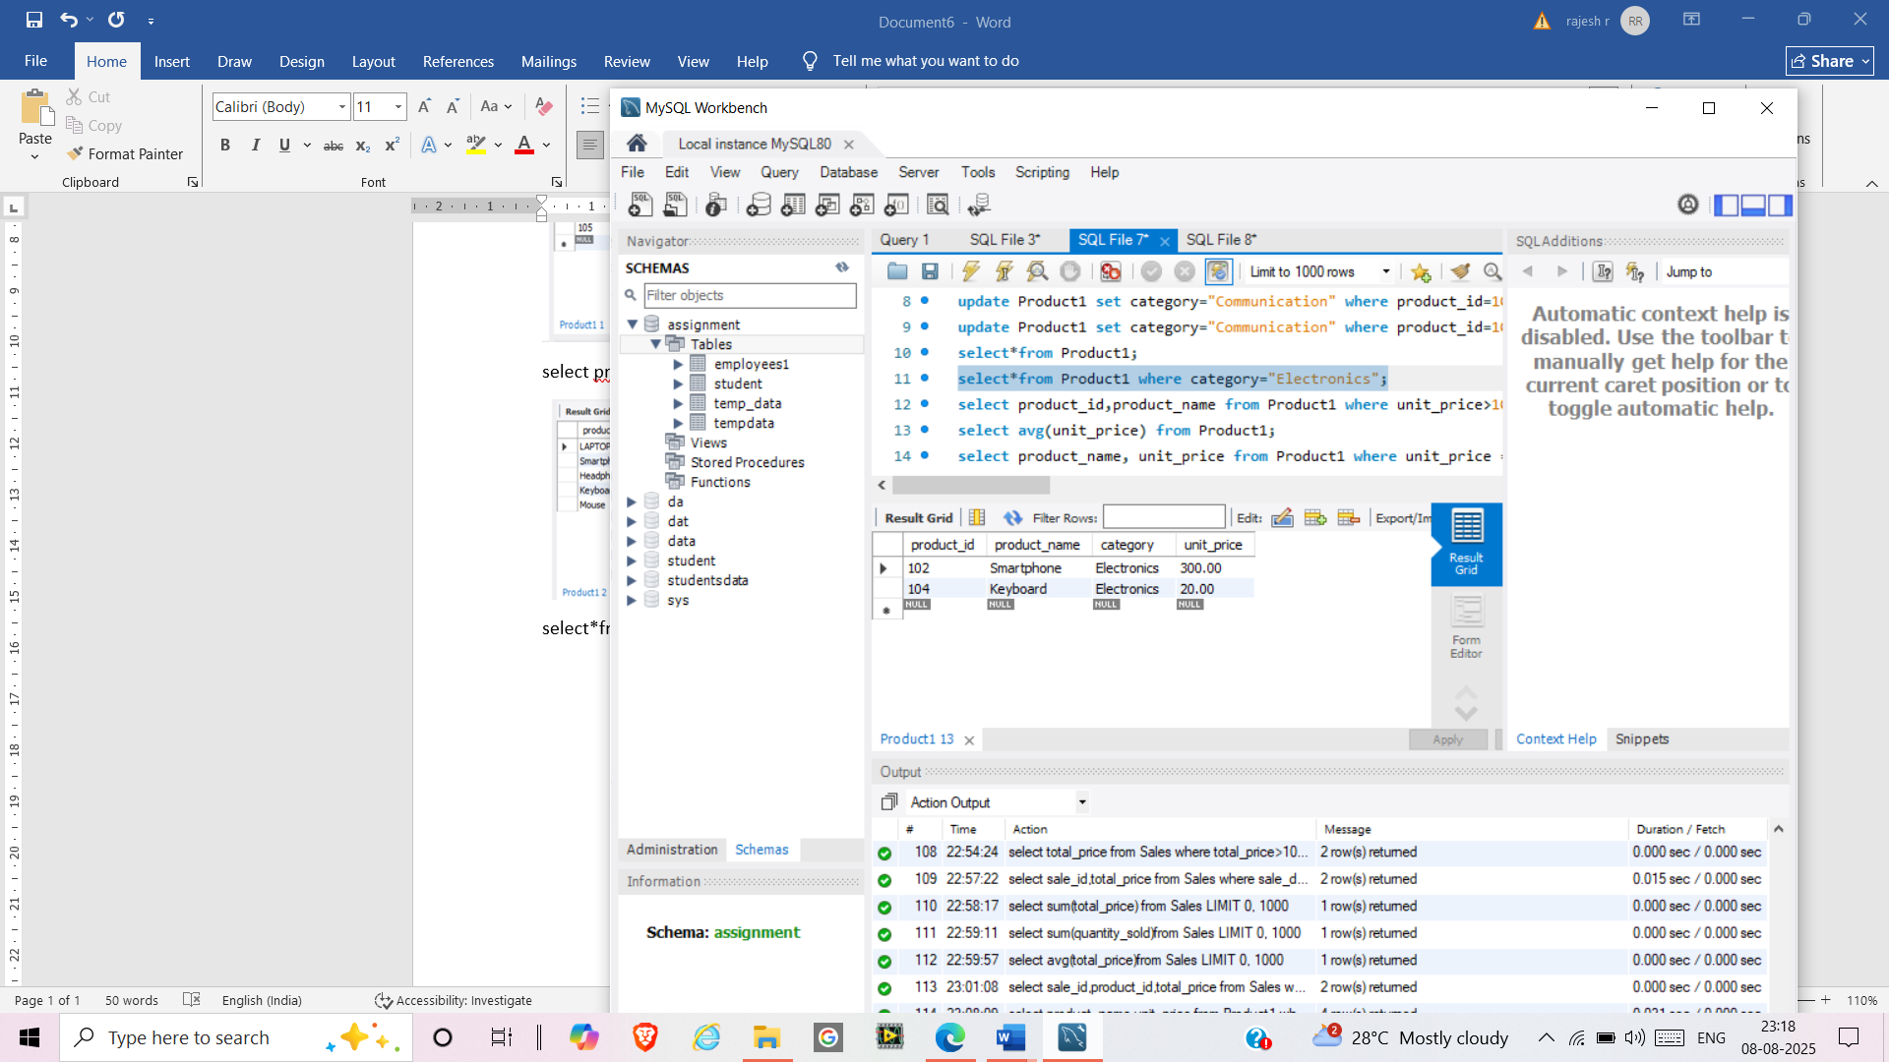

select product_id,product_name from Product1 where unit_price>100;

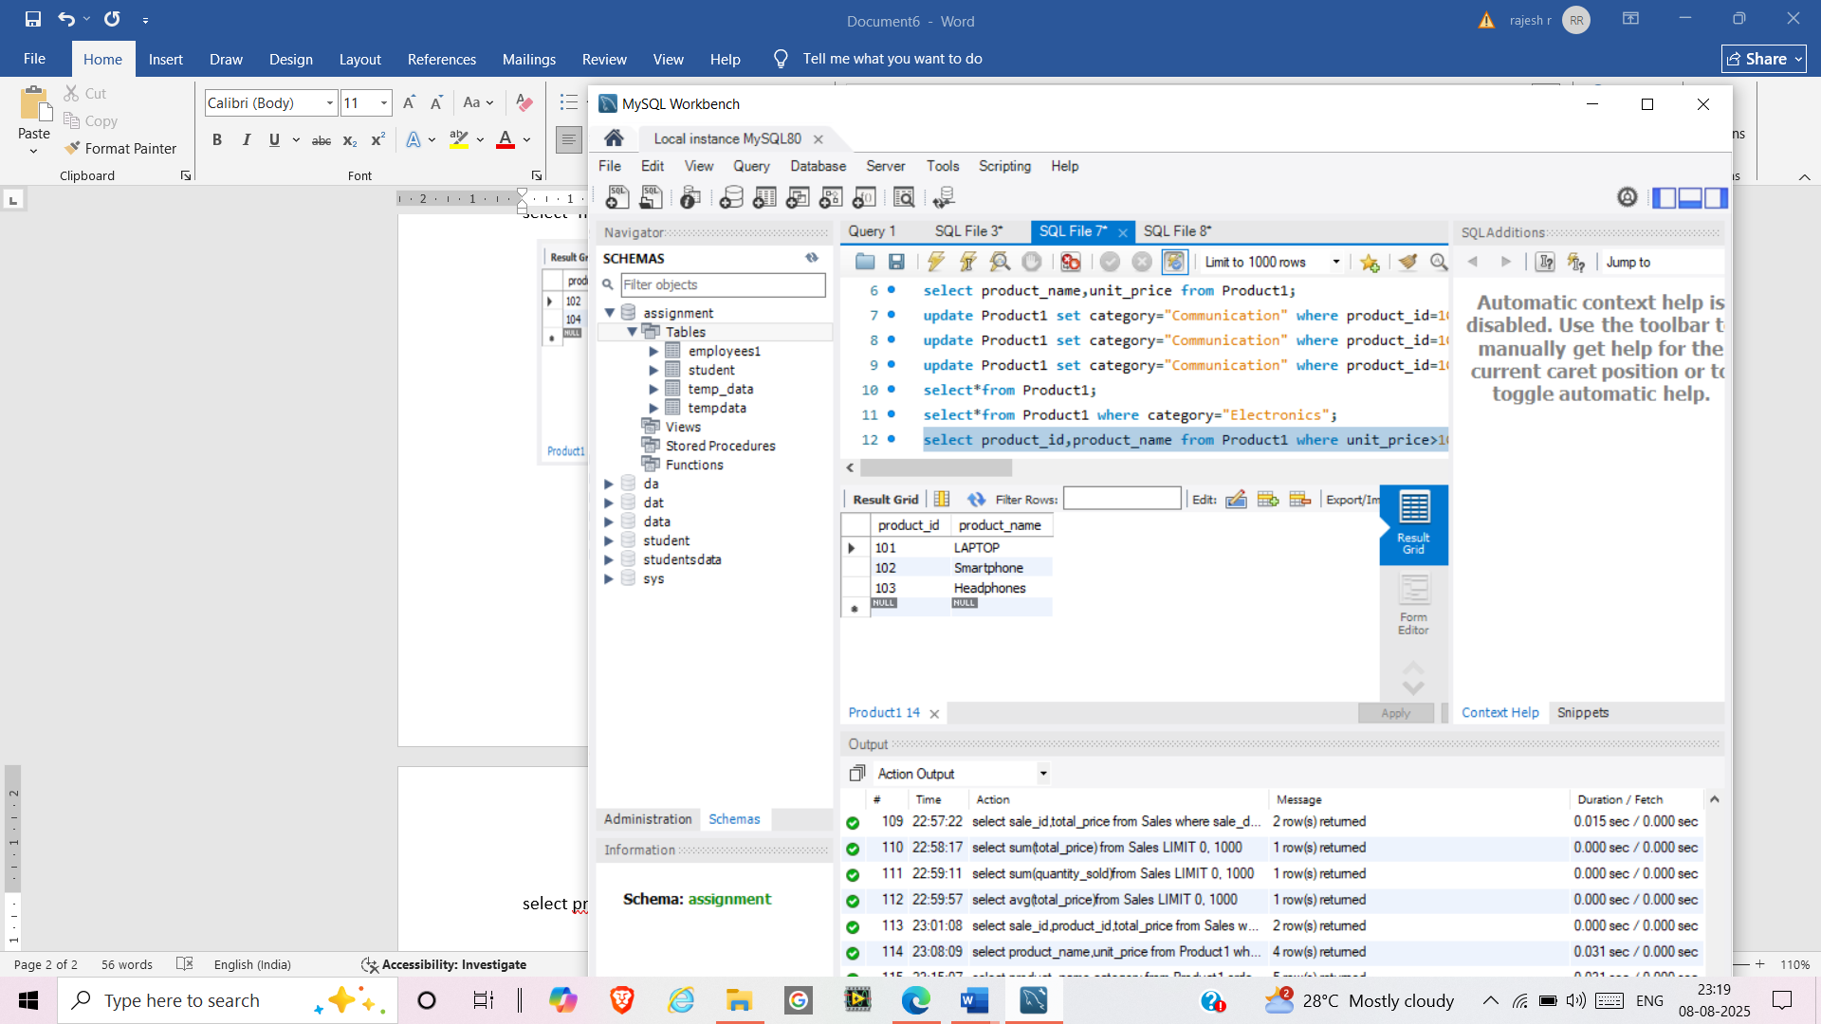

select avg(unit_price) from Product1;

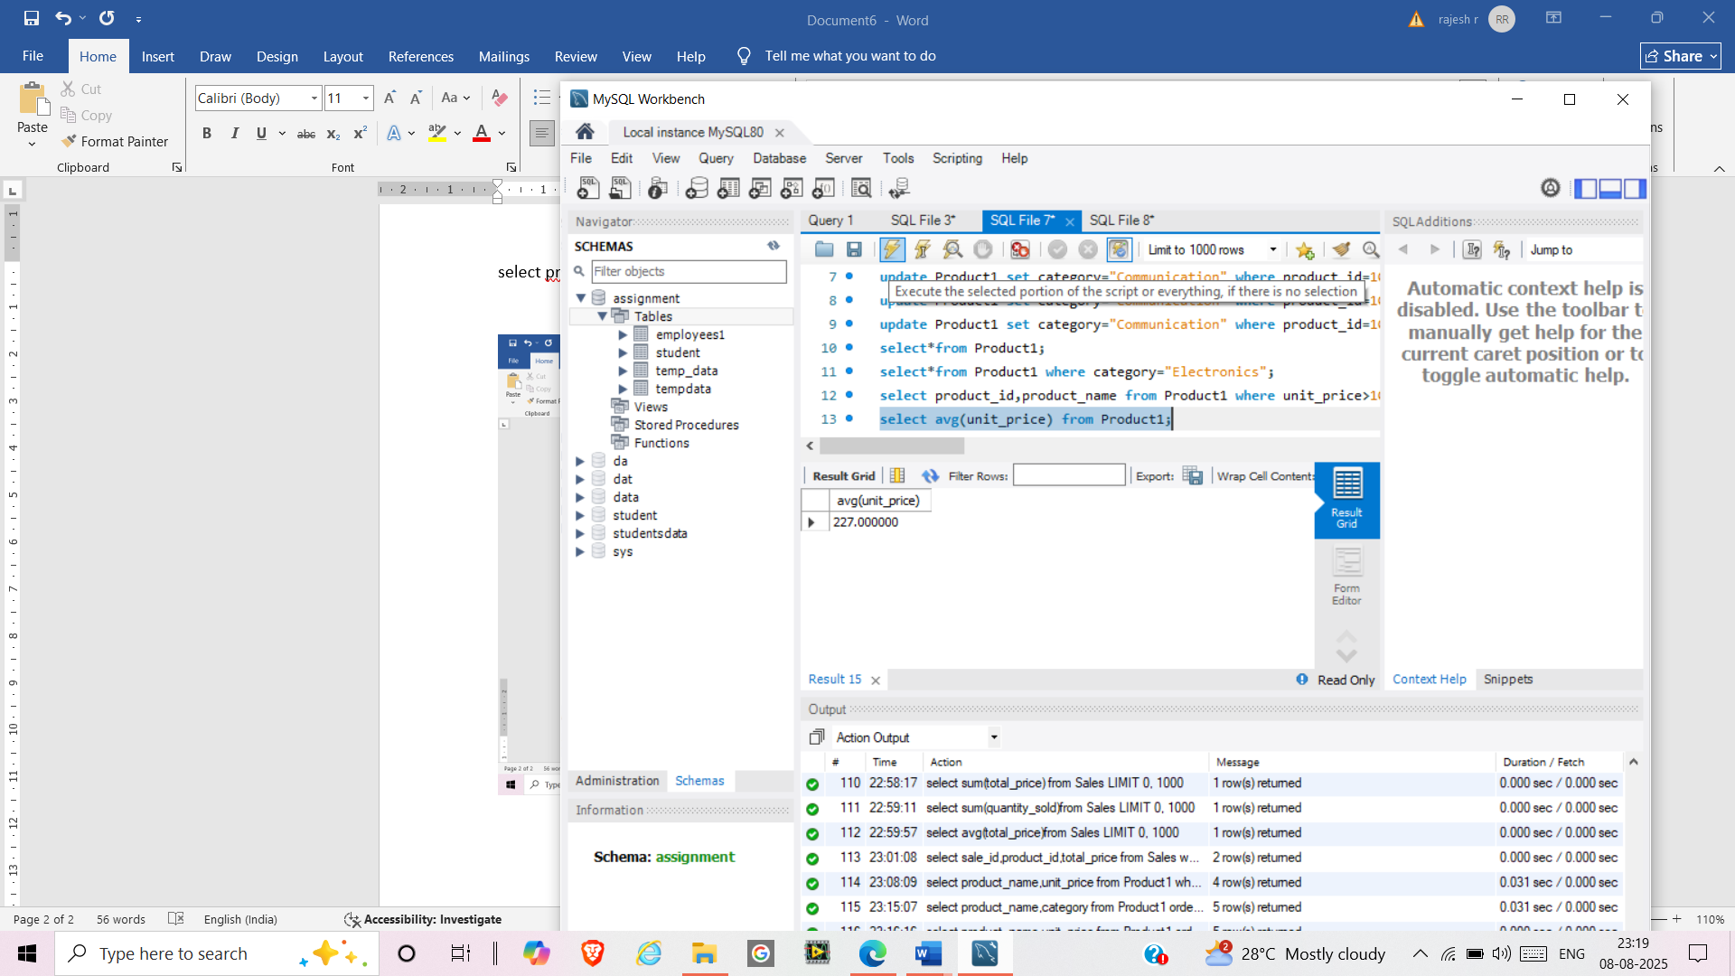

select product_name, unit_price from Product1 where unit_price = (select MAX(unit_price) from Product1);

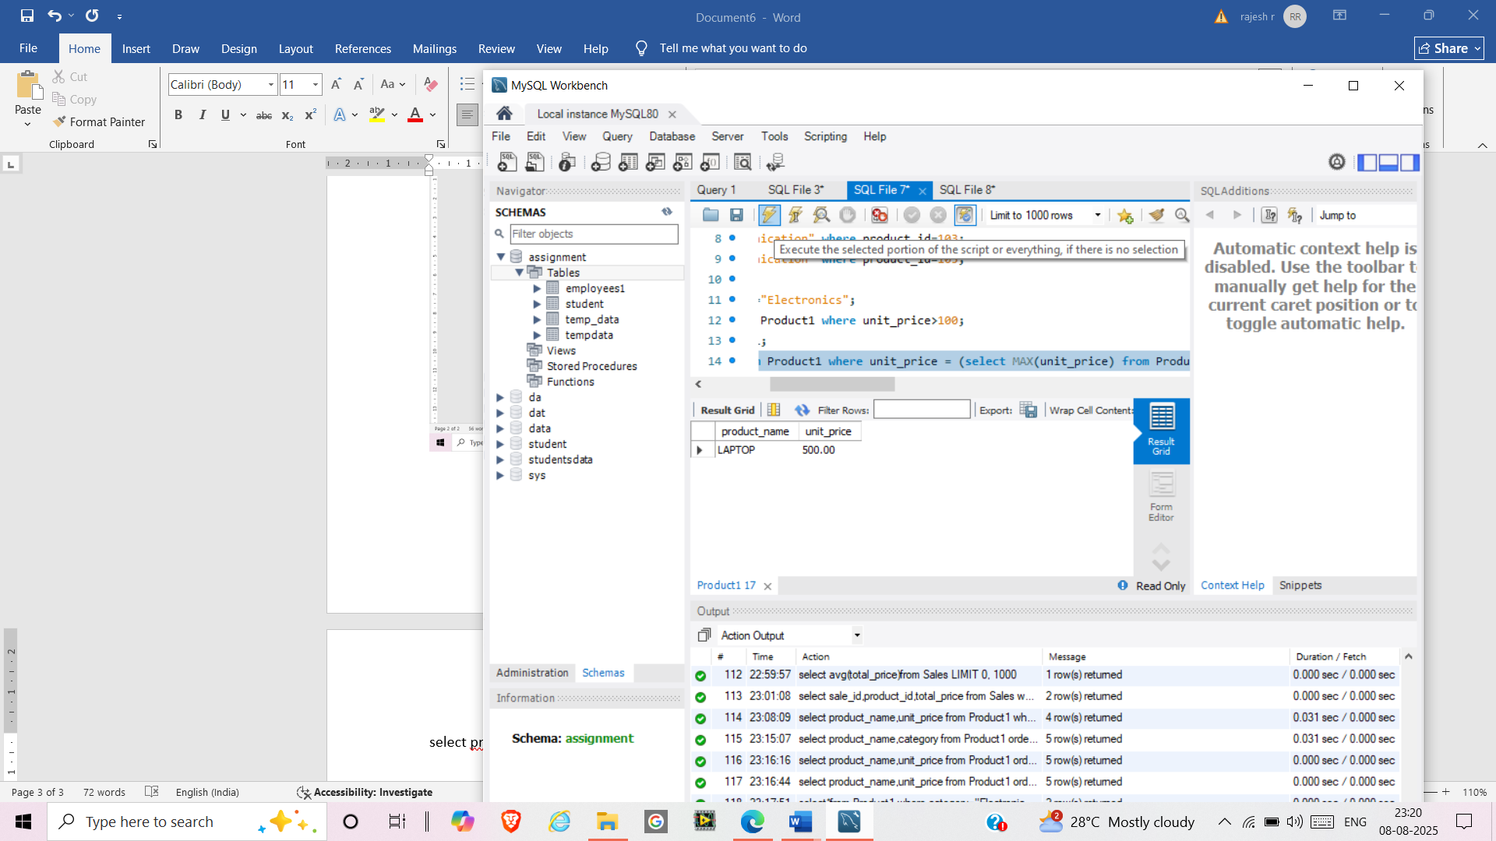

select product_name,unit_price from Product1 where unit_price between '20' and '600';

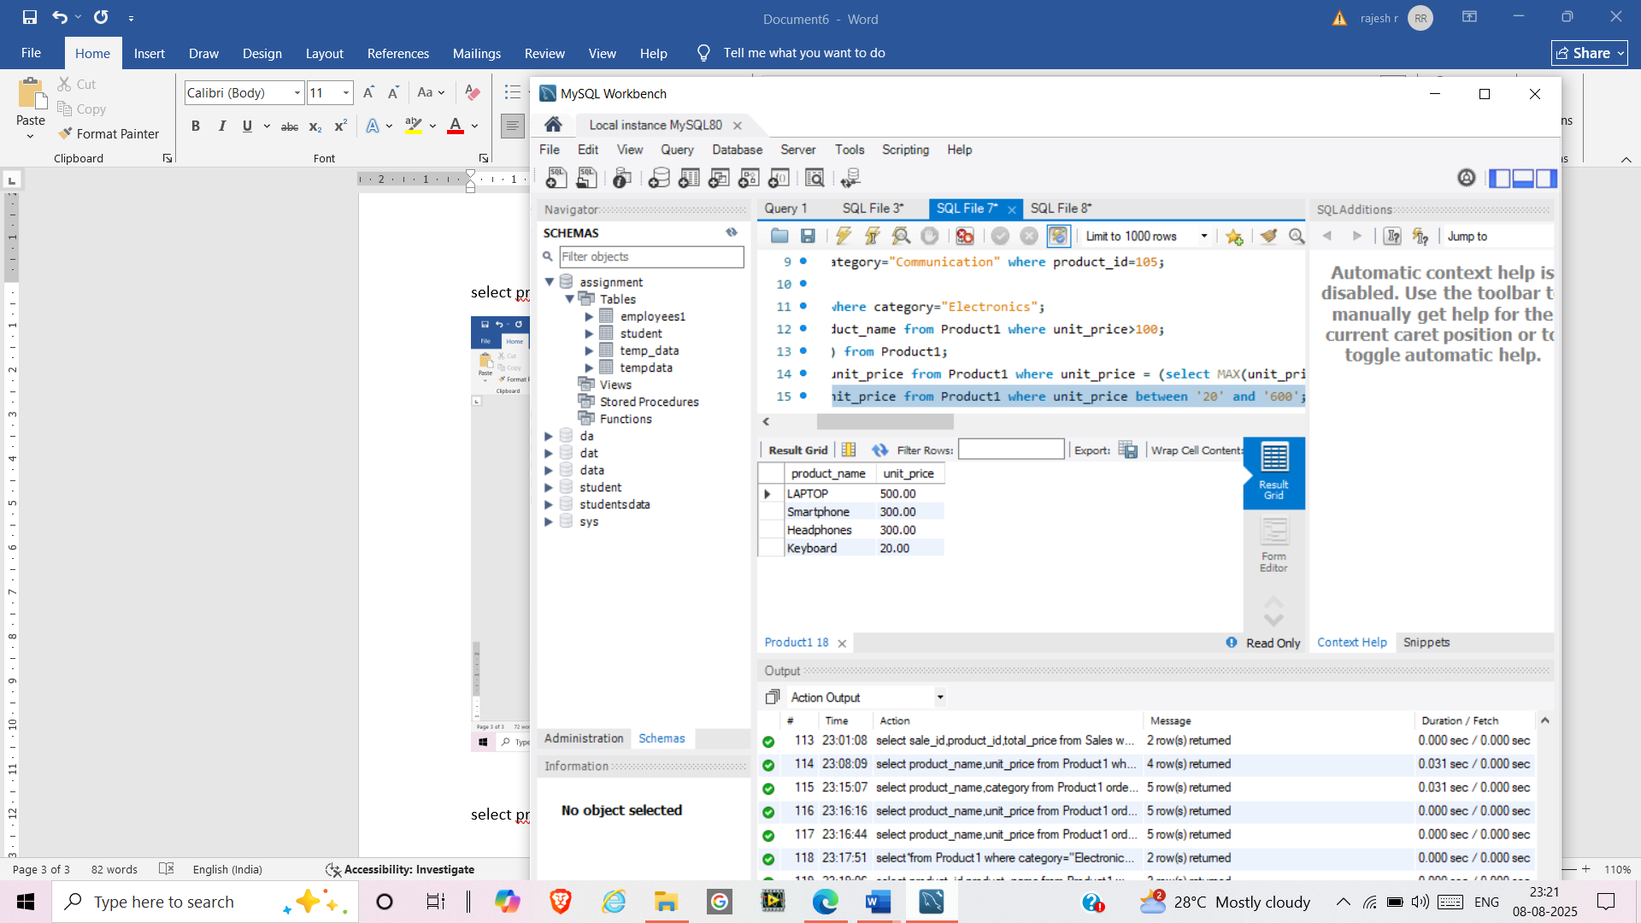

select product_name,category from Product1 order by category asc;

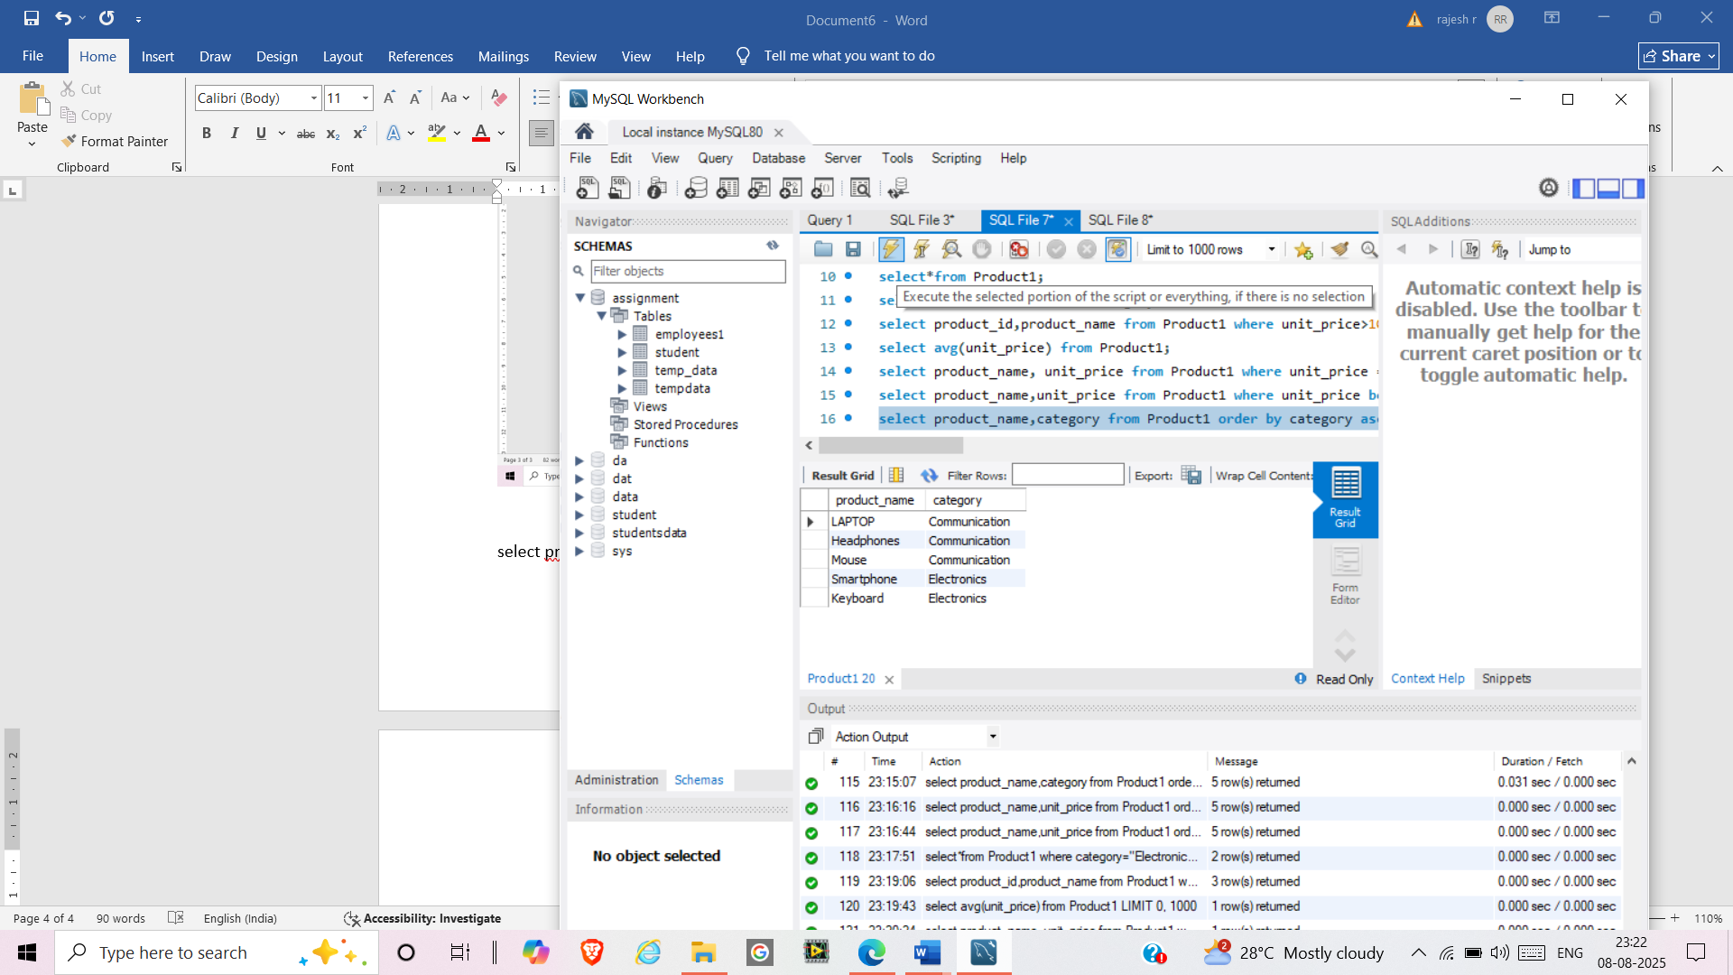

select product_name,unit_price from Product1 order by unit_price desc;

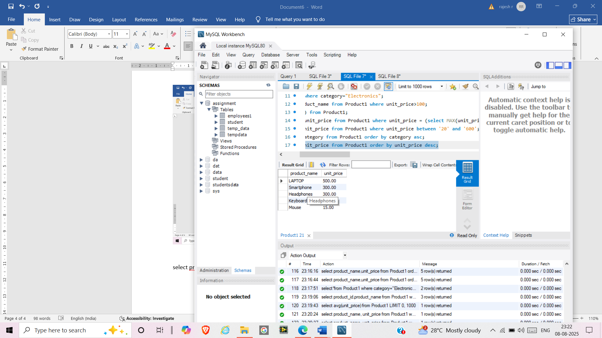

create schema da;

use da;

CREATE TABLE Sales (sale_id INT PRIMARY KEY,product_id INT,quantity_sold INT,sale_date DATE,total_price DECIMAL(10, 2),FOREIGN KEY (product_id) REFERENCES Product1(product_id));

INSERT INTO Sales (sale_id, product_id, quantity_sold, sale_date, total_price) VALUES(1, 101, 5, '2024-01-01', 2500.00),(2, 102, 3, '2024-01-02', 900.00),(3, 103, 2, '2024-01-02', 60.00),(4, 104, 4, '2024-01-03', 80.00),(5, 105, 6, '2024-01-03', 90.00);

select*from Sales;

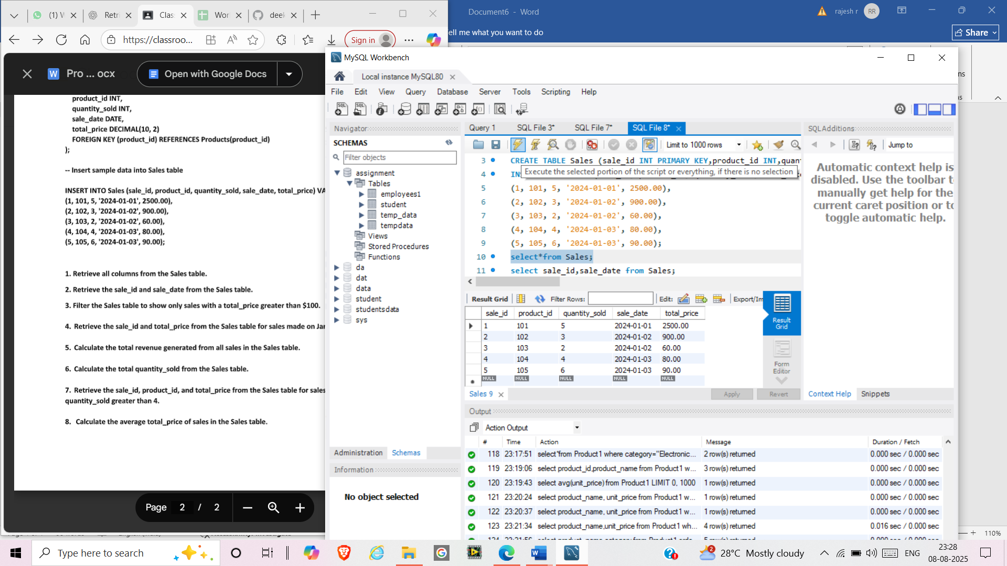

select sale_id,sale_date from Sales;

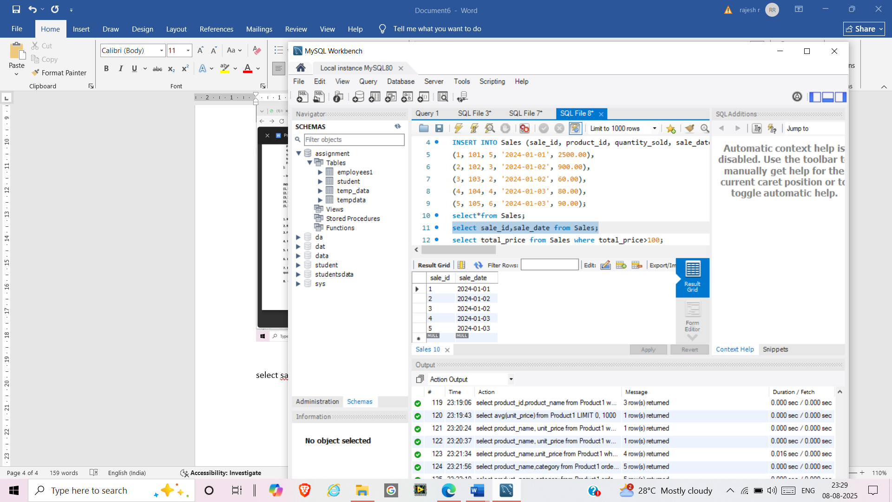

select total_price from Sales where total_price>100;

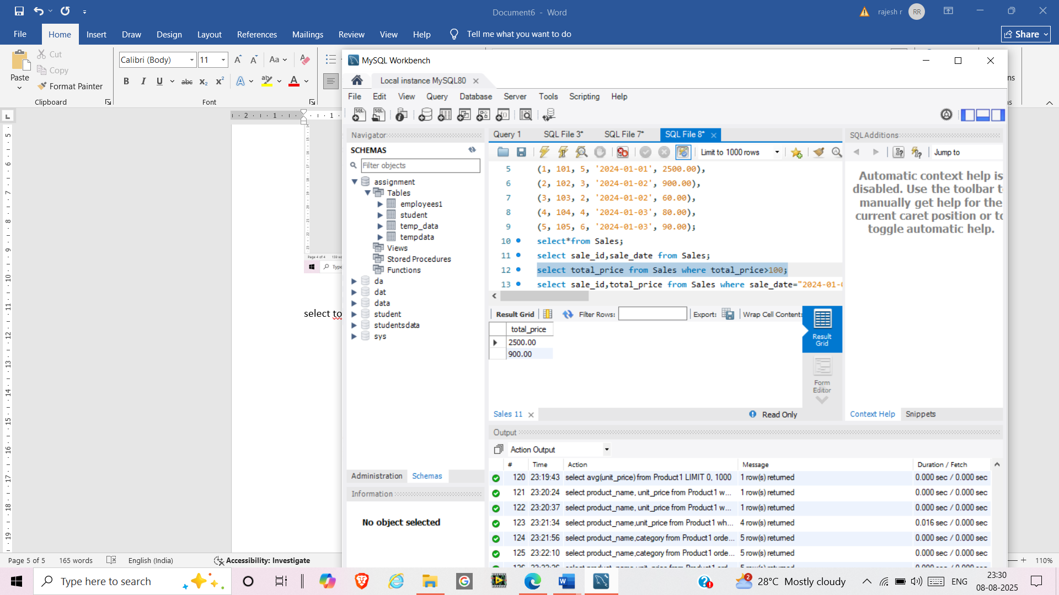

select sale_id,total_price from Sales where sale_date="2024-01-03";

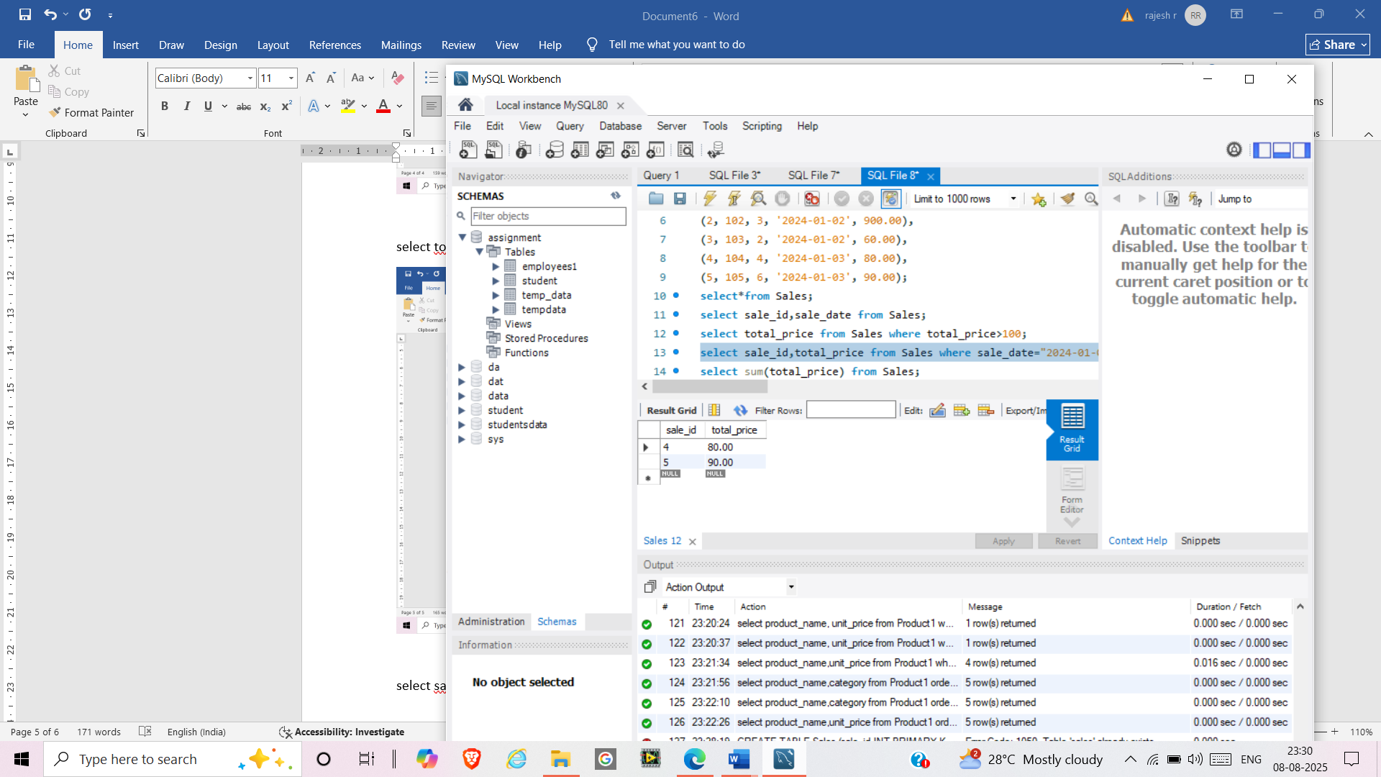

select sum(total_price) from Sales;

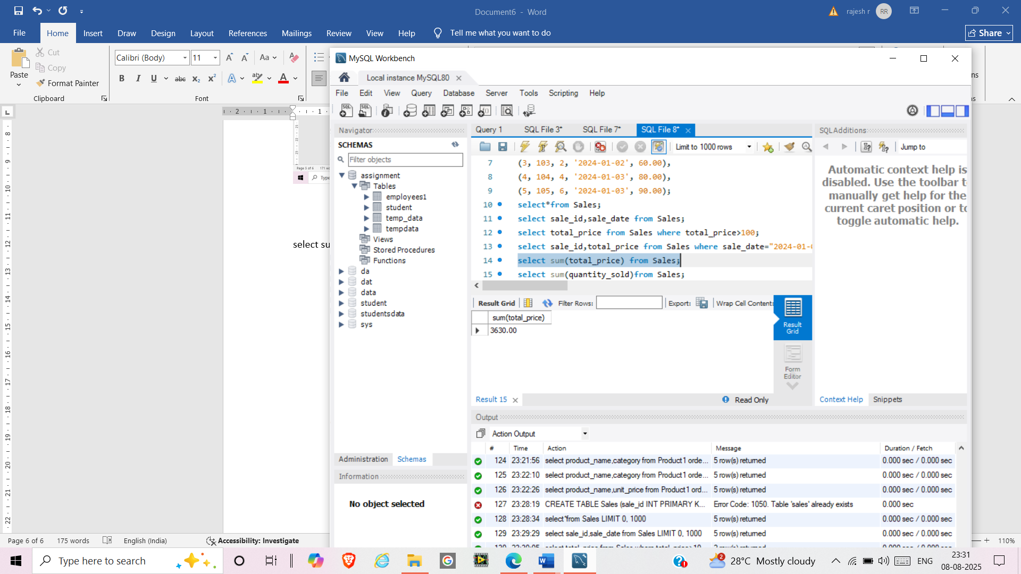

select sum(quantity_sold)from Sales;

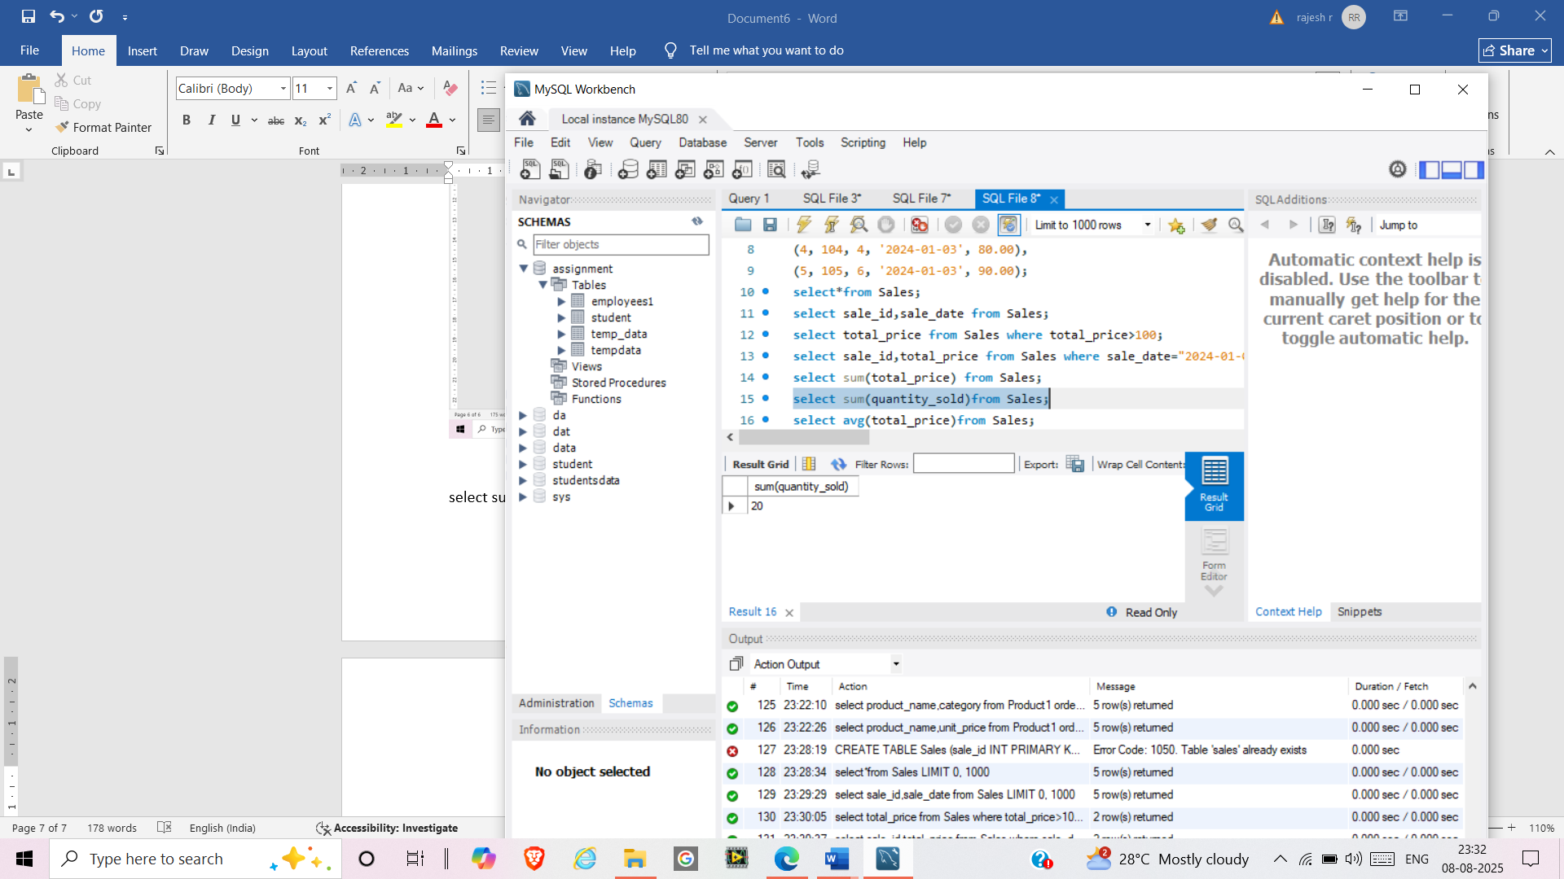

select avg(total_price)from Sales;

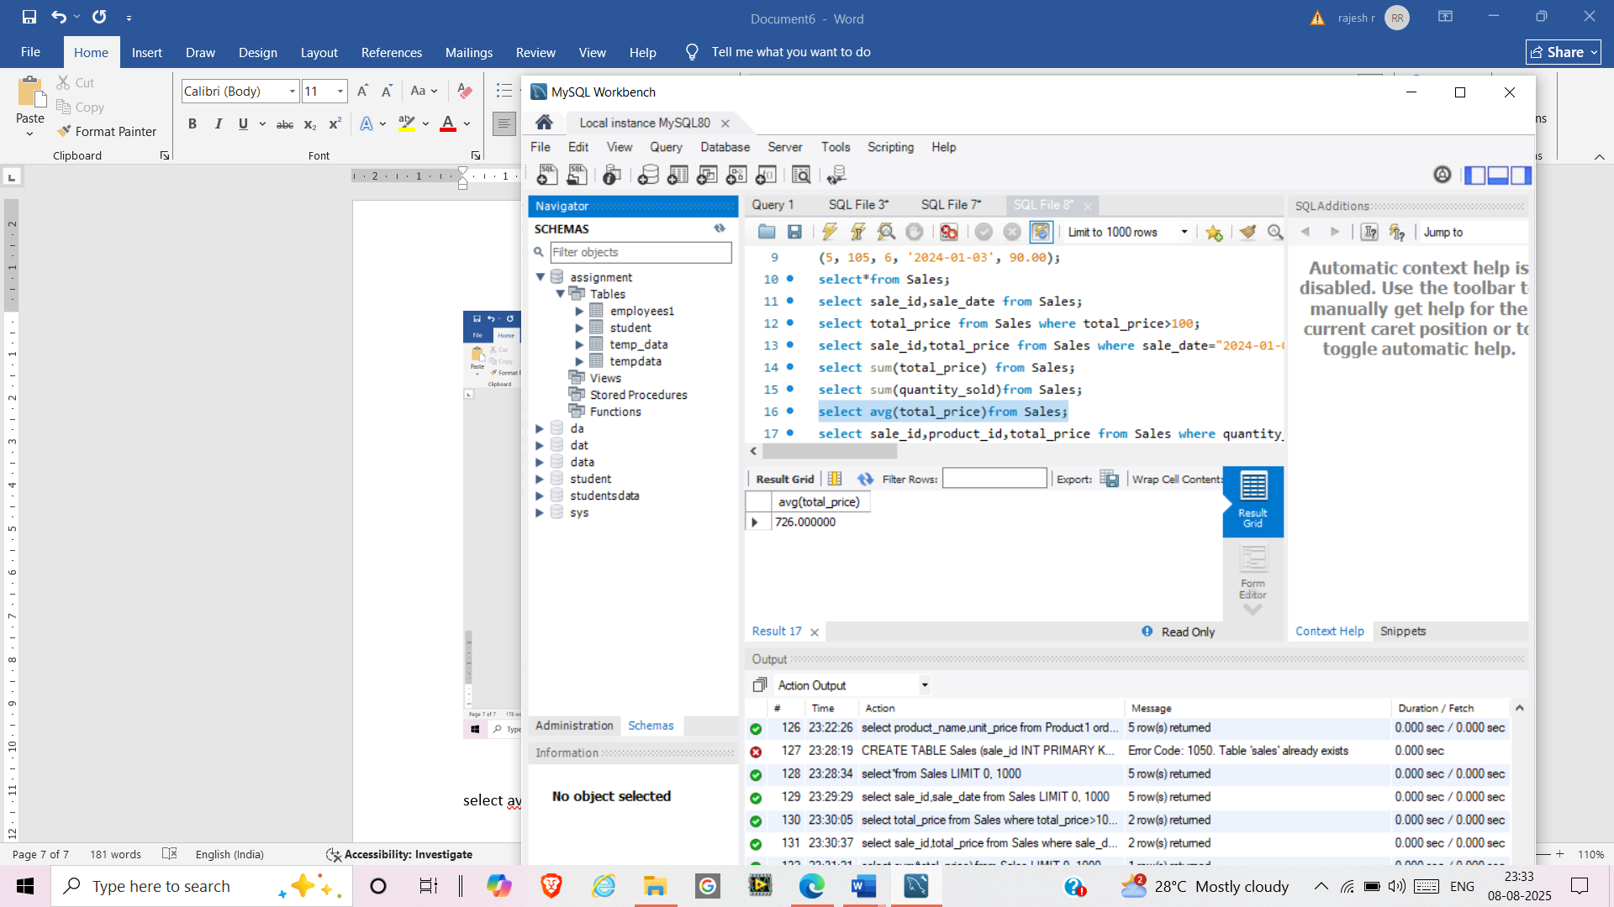

select sale_id,product_id,total_price from Sales where quantity_sold>4;

